**Unit:- 3** **Website Management**

* **Domain Management:-** The e-commerce domain refers to the area of business that focuses on conducting commercial transactions online. It involves buying and selling products or services over the internet using electronic means. E-commerce has revolutionized the way businesses operate and has become increasingly popular with the widespread adoption of the internet. Domain management, also known as domain name management, is the practice of keeping a portfolio of web domains active, registered, stable, and secured from a broad range of threats. Effective domain management includes renewing domain name registrations for all the domains within an organization’s portfolio, determining nameservers and hosting providers, and making adjustments to domain names and DNS settings when required. Domain management teams may also monitor web searches for the domain, track similar domain names that may cause harm to the reputation or authority of a brand, and deploy and manage security solutions that protect the domain and DNS records.

## What is a web domain:- A web domain name is a string of text that users type into a browser window — such as “example.com” — to reach a specific website. Domain names are meant to be easily read and remembered by users, making it easier to navigate the web and visit specific sites. Each domain name has an IP address, an alphanumeric string that can be read by machines. To translate a web domain into an IP address, computers and devices communicate with the domain name system (DNS). DNS serves as a kind of phone book for the internet, quickly providing devices and computers with the actual IP address of a web domain that a user enters in a web browser.

## Why is Domain important:- Corporate domain names are the centerpiece of an organization’s online presence and are often equated with the brand, especially when the domain name is synonymous with the company name. Threats like phishing or copycat sites can cause significant harm to customers, damaging relationships with the organization. Other threats like cybersquatting or counterfeit sellers may also degrade the credibility of a domain name and the brand. The industry of domain management continues to evolve at a rapid pace. New global top-level domain names (TLD) and second-level and third-level country codes add more complexity for domain management teams seeking to register and manage any domain that is similar to their organization’s core domain. The process of managing an international domain portfolio has grown more complex, with less certainty about where, when, and how domains must be registered.

## What are Threats to Domains:-

* **Phishing websites**. Phishing websites are copycat sites that look and feel identical to a trusted brand and are registered under a similar domain. Using a variety of tactics, threat actors direct unsuspecting customers to a phishing website, where they may be asked to enter sensitive information like login credentials or account numbers.
* **Cybersquatters:-** Cybersquatting is the practice of registering, selling, or using a domain name to profit off the brand equity of someone else’s trademark. Often, cybersquatters will buy domain names that use the name of existing businesses and attempt to sell those domains to the rightful owner for a profit.
* **Missed renewals:-** Registration for each domain must be renewed every few years. When a domain renewal is missed, websites connected to the domain will be unavailable to users and customers. Cybersquatters may quickly snap up the registration and sell it back to the organization for a hefty sum.
* **Multiple registrars;-** Problems often arise when an organization’s many domains are registered with a variety of registrars. Tracking renewals becomes more difficult, as does ensuring that each of the registrars has strong security controls in place to protect the domains from threats.
* **Key Components of the E-commerce Domain:-**

1. **Online Shopping Platforms:-** These are websites or applications that serve as a digital storefront where customers can browse and purchase products or services. Examples include Amazon, eBay, Shopify, and Alibaba.
2. **Product Catalog:-** The product catalog includes detailed information about the products or services available for purchase, such as descriptions, images, pricing, and availability. It allows customers to make informed decisions about their purchases.
3. **Shopping Cart:-**The shopping cart functionality enables customers to select and collect items they wish to purchase while they continue browsing. It provides a convenient way to manage multiple products before proceeding to the checkout process.
4. **Payment Gateways:-**Payment gateways are online services that facilitate secure transactions by encrypting sensitive financial information. They enable customers to make payments using various methods, such as credit cards, debit cards, digital wallets (e.g., PayPal), or bank transfers.
5. **Order Management:-**This component involves the processing and fulfillment of customer orders. It includes tasks like order confirmation, inventory management, order tracking, and shipment logistics to ensure timely delivery.
6. **Customer Accounts:-**E-commerce platforms often offer customer account functionalities. Customers can create accounts to save their preferences, track order history, manage payment methods, and receive personalized recommendations.
7. **Security:-** E-commerce platforms must prioritize security to protect customer information and financial data. Measures like SSL/TLS encryption, secure login mechanisms, and adherence to PCI-DSS (Payment Card Industry Data Security Standard) help safeguard sensitive information.
8. **Logistics and Shipping:-** Efficient logistics and shipping management are essential for successful e-commerce operations. This involves coordinating inventory, packaging, shipping carriers, tracking, and handling returns or exchanges.
9. **Customer Support:-** Providing customer support is crucial in the e-commerce domain. This may include channels such as live chat, email, or phone support to address customer inquiries, resolve issues, and provide assistance throughout the purchasing process.
10. **Marketing and Promotions:-** E-commerce businesses employ various marketing techniques to attract customers, increase visibility, and drive sales. This may involve search engine optimization (SEO), digital advertising, social media marketing, and personalized recommendations based on customer behavior.
11. **Analytics and Insights:-** E-commerce platforms collect and analyze data to gain insights into customer behavior, preferences, and trends. This information helps optimize marketing strategies, improve user experience, and make data-driven business decisions.
12. **Mobile Commerce:-**With the rise of mobile devices, mobile commerce (m-commerce) has become increasingly important. E-commerce platforms need to provide mobile-friendly interfaces and applications to cater to users accessing their services through smartphones and tablets.

The e-commerce domain encompasses a wide range of businesses, including **B2C**(business-to-consumer) and **B2B**(business-to-business) models, as well as various sectors such as retail, travel, hospitality, and services. It offers convenience, global reach, and new business opportunities for both traditional brick-and-mortar companies and online-only enterprises.

* **Domain Types:-** E-commerce and M-commerce are two types of digital commerce that are related but distinct. E-commerce, or electronic commerce, is the buying and selling of goods and services online using desktop or laptop computers. M-commerce, or mobile commerce, is the buying and selling of goods and services online using mobile devices like smartphones, tablets, or other wireless devices. E-commerce can be referred to as an umbrella word for the whole process of buying and selling goods and services online. On the other hand, m-commerce can be referred to as a sub-division of ecommerce that focuses on the buying and selling of goods and services through a mobile device. The e-commerce domain refers to the area of business that focuses on conducting commercial transactions online. It involves buying and selling products or services over the internet using electronic means. E-commerce has revolutionized the way businesses operate and has become increasingly popular with the widespread adoption of the internet. The e-commerce domain encompasses a wide range of businesses, including B2C (business-to-consumer) and B2B (business-to-business) models, as well as various sectors such as retail, travel, hospitality, and services. It offers convenience, global reach, and new business opportunities for both traditional brick-and-mortar companies and online-only enterprises. An e-commerce domain is a web address for an online store that serves as a unique identifier. The Domain Name System (DNS) has different types of domains, each with a specific purpose and audience. Understanding these types can help improve your web presence and branding strategy.
  + **Domain Types in E-commerce:-**
* **B2C (Business-to-Consumer):** Businesses sell products or services directly to consumers. Examples include online retailers like Amazon and direct-to-consumer brands like Warby Parker.
* **B2B (Business-to-Business):** Transactions occur between businesses. This model is common for wholesale suppliers or platforms like Alibaba that facilitate bulk transactions between companies.
* **C2C (Consumer-to-Consumer):** Individuals sell products or services to other individuals. Platforms like eBay and Craigslist facilitate this type of commerce.
* **C2B (Consumer-to-Business):** Individuals sell products or services to businesses. This model includes freelancers offering services to companies through platforms like Upwork or Fiverr.
* **B2G (Business-to-Government):** Businesses provide goods or services to government agencies. This type of e-commerce often involves formal procurement processes and contracts.

### ****2. Domain Types in M-commerce****

M-commerce focuses on transactions conducted via mobile devices, and can also be categorized into different types:

* **Mobile Shopping:** This includes mobile-optimized websites and apps where users can browse and purchase products. Examples are mobile versions of e-commerce sites like Amazon or dedicated mobile shopping apps.
* **Mobile Banking:** Services that allow users to conduct financial transactions via mobile apps, such as checking account balances, transferring money, or paying bills.
* **Mobile Payments:** Solutions that facilitate payments through mobile devices, including digital wallets (like Apple Pay or Google Wallet) and payment apps (like Venmo).
* **Mobile Advertising:** Ads that target users on their mobile devices, using strategies like location-based targeting or in-app advertisements.
* **Location-Based Services:** Features that leverage GPS to provide localized offers or services, such as finding nearby stores or receiving promotional notifications based on location.

In summary, **E-commerce domain types** categorize the nature of transactions and participants, while **M-commerce domain types** focus on how these transactions and interactions are facilitated through mobile technology.

* **In Computer Science Domain Types E- Commerce M- Commerce:-**

#### ****1. Data Domain Types:-****

* **Primitive Types:-** Basic data types provided by programming languages, such as integers, floats, characters, and booleans.
* **Composite Types:-** Data structures that combine primitive types, such as arrays, lists, records, and tuples.
* **Abstract Data Types (ADTs):-** High-level data types defined by their behavior from the point of view of a user, such as stacks, queues, and graphs.

#### ****2. Domain-Specific Languages (DSLs):-****

* **Internal DSLs:-** Languages embedded in a host language (e.g., SQL in Python).
* **External DSLs:**- Standalone languages designed for a specific domain (e.g., HTML for web pages).

#### ****c. 3. Domain Modeling:-****

* **Entities:-** Objects or concepts within a domain (e.g., Customer, Order).
* **Value Objects:-** Objects that represent descriptive aspects of the domain (e.g., Address, Money).
* **Aggregates:-** Groups of related entities and value objects that are treated as a unit (e.g., an Order and its associated LineItems).

### 2. ****In Mathematics:-****

**Domain Types** **typically refer to the domain of functions or relations:**

#### ****a. Domain of a Function:-****

* **Definition:-** The set of all possible input values (x-values) for which the function is defined.
* **Example:-** For the function f(x)=xf(x) = \sqrt{x}f(x)=x​, the domain is x≥0x \geq 0x≥0 because you cannot take the square root of a negative number in the real number system.

#### ****b. Domain of Relations:-****

* **Definition**: The set of all possible first components of ordered pairs in a relation.
* **Example**: For the relation RRR on set A×BA \times BA×B, if R={(a1,b1),(a2,b2)}R = \{(a_1, b_1), (a_2, b_2)\}R={(a1​,b1​),(a2​,b2​)}, the domain is {a1,a2}\{a_1, a_2\}{a1​,a2​}.

### 3. ****In Networking:-****

**Domain Types** relate to network management and naming:

#### ****a. Domain Names:-****

* **Top-Level Domains (TLDs):-**The last segment of a domain name (e.g., .com, .org).
* **Second-Level Domains:-** The segment directly to the left of the TLD (e.g., "example" in "example.com").
* **Subdomains:-** Domains that are part of a larger domain (e.g., "blog.example.com").

#### ****b. Domain Name System (DNS):-****

* **DNS Records**: Various types such as A (address record), MX (mail exchange record), and CNAME (canonical name record).

### 4. ****In Economics and Business:-****

**Domain Types** might refer to:-

#### ****a. Market Domains:-****

* **Consumer Markets**: For goods and services purchased by individuals.
* **Business Markets**: For products and services purchased by businesses.

#### ****b. Product Domains:-****

* **Core Products**: The primary goods or services offered by a company.
* **Extended Products**: Additional features or services that complement the core product.

The concept of "domain types" can vary widely depending on the context. In computer science, it often pertains to data structures and domain-specific languages. In mathematics, it deals with the input values of functions or relations. In networking, it relates to domain names and DNS. And in economics, it involves market and product classifications. Each domain type is crucial for its respective field and helps structure and categorize information effectively.

* **Domain Search:-** Imagine your e-commerce website is the same as your flagship store in the online marketplace. The search bar acts as your customers’ guide, either leading them to satisfaction or leaving them frustrated. Just as a physical store’s layout affects shoppers, your digital store’s search bar and website design deeply impact online visitors. In this blog, discover how a user-friendly e-commerce search bar and an aesthetically designed website can be your most potent allies in attracting, engaging, and converting online shoppers. A domain name is a human-readable address used for identifying and accessing websites on the internet.

It serves as a unique identifier for a specific web location, allowing users to easily navigate the web by typing or clicking on familiar names (e.g.,www.example.com.) rather than remembering complex numerical IP addresses. Domain names are essential for online branding, marketing, and navigation, making the internet more user-friendly and accessible. They are typically registered through domain registrars and require periodic renewal to maintain ownership.

## Where is the domain name in a URL:- The domain name in a URL (Uniform Resource Locator) is typically found immediately after the protocol (e.g., “http://” or “https://”) and the double slashes (“://”). It appears before any additional path or resource identifiers. For example, in the URL “https://www.example.com/page,” the domain name is “www.example.com.”

The domain name in a URL (Uniform Resource Locator) is typically found immediately after the protocol (e.g., “http://” or “https://”) and the double slashes (“://”). It appears before any additional path or resource identifiers. For example, in the URL “https://www.example.com/page,” the domain name is [www.example.com.](http://www.example.com.)

* **Registration:**Domain names are purchased through domain registrars, which act as intermediaries between domain seekers and the domain governing bodies, such as ICANN (Internet Corporation for Assigned Names and Numbers). Users can choose a unique domain name, often with a top-level domain (TLD) option like .com, .org, or country-code TLDs. The registration process involves providing contact information and agreeing to terms and conditions, including periodic renewal fees, to secure the rights to use the domain.
* **DNS (Domain Name System):**The DNS is a distributed network of servers that serve as the internet’s address book. When you enter a domain name in your web browser, the browser sends a query to a DNS server to translate the human-readable domain (like “www.example.com”) into an IP address, such as “192.0.2.1.” which is necessary for computers to identify the web server associated with that domain.
* **IP address resolution:**The DNS server searches its database for the requested domain name. If it finds a match, it retrieves the corresponding IP address associated with that domain. If the DNS server can’t find a match, it may query other authoritative DNS servers until it locates the correct IP address. Once found, this IP address is returned to your device.
* **Website retrieval:**Armed with the IP address, your web browser connects to the web server associated with the domain. It sends a request for the specific web page or resource you’re seeking. The web server then processes your request and transmits the requested web page or content, which your browser renders for you to view on your screen.

Domain names simplify internet navigation, as users can remember and type them instead of complex IP addresses, making it easier to access websites and online resources.

1. **Type-ahead Search:-** Type-ahead search, also known as autocomplete, is a feature that predicts and suggests search terms as users type into the search bar. This seemingly simple addition can significantly enhance the user experience.

Imagine a potential customer visiting your online store, eagerly searching for a specific product. With type-ahead search, as soon as they start typing, your website offers helpful suggestions, making their search quicker and less error-prone. This feature not only accelerates the search process but also minimizes errors, providing a seamless user experience. For business owners, it translates to higher chances of customers swiftly locating what they need, leading to increased sales and overall customer satisfaction.  A Website is a collection of web pages that is used to convey specific and helpful information to specific users. Websites are also used to increase business, reach more customers, generate more qualified leads, etc.  Domain names are formed by the rules and procedures of the Domain Name System (DNS). Any name registered in the DNS is a domain name. Domain names are organized in subordinate levels (subdomains) of the DNS root domain, which is nameless. The first-level set of domain names are the top-level domains (TLDs), including the generic top-level domains (gTLDs), such as the prominent domains com, info, net, edu, and org, and the country code top-level domains (ccTLDs). Below these top-level domains in the DNS hierarchy are the second-level and third-level domain names that are typically open for reservation by end-users who wish to connect local area networks to the Internet, create other publicly accessible Internet resources or run websites. The registration of a second- or third-level domain name is usually administered by a domain name registrar who sell its services to the public.

**2. Second-Level Domain (SLD):** -This is the core part of the domain name, providing the primary identity for a website.In the web address “example.com,” the term “example” represents the second-level domain

**3.Top-Level Domain (TLD):** The TLD is the rightmost part of the domain, representing the category or purpose of the website. Common TLDs include .com, .org, and .net. Country-code TLDs (ccTLDs) like .uk or .ca are associated with specific countries.

These different parts combine to form a complete domain name, providing a structured and intuitive way to locate and access websites on the internet.

## What are the different types of domain names:-

There are various types of domain names, each designed for specific purposes and different needs. Picking the right domain name and extension depends on what your website is for, who your audience is, and your branding goals. These different types have their own benefits and can make a big difference in how people find and recognize your website.

* **Generic Top-Level Domains (gTLDs):**- These are the most common domain types and include familiar extensions like .com, .org, and .net. They are versatile and appropriate for a wide array of websites.
* **Country Code Top-Level Domains (ccTLDs):-** These domain extensions are associated with specific countries or territories, such as .uk for the United Kingdom, [.in](https://www.bigrock.in/tld/in-domain) for India or .ca for Canada. They are often used to denote a local or regional presence.
* **Sponsored Top-Level Domains (sTLDs):** - These are specialized domain extensions often managed by organizations or industries. Examples include .gov for government entities or .edu for educational institutions.
* **New gTLDs:-**  Introduced in recent years, these extensions have expanded options beyond traditional gTLDs, such as .app, .blog, and .guru. They can be more descriptive and relevant to specific website content.
* **Brand TLDs:-** Some companies have their own domain extensions, like .apple or .google, which reinforce their brand identity.
* **Domain Registration & Renewal:-** Domain names are often registered and used for company websites, specific product websites and for e-mail addresses. However, registering a domain name can be complex, due to the rules and regulations surrounding who can buy them, when, and for how long. There are also rules that determine when domains can be renewed after they expire as well as if additional fees apply. Let’s explore the basics of website domain registration, renewal and expiration. Domain names start life as an idea. Once a search is done to confirm the domain name is available, it can be registered for the desired number of years, up to a maximum of 10 years. Each time the domain approaches its expiry date, it can be renewed. The expiry date can never be more than 10 years in the future, so a domain can only be renewed up to a maximum of 9 years at one time. If a domain is not renewed before the expiry date is reached, it enters what is commonly referred to as the Grace Period. The Grace Period typically lasts between 0 and 30 days and often does not have any additional costs associated with it allowing a domain name to still be renewed at the normal rate.

When the grace period elapses, most domains then enter a status of Redemption. Redemption is the last chance to renew a domain before it becomes available for registration again and often coincides with registries putting the domain up for auction. Domains can still be renewed while in the redemption status (providing it hasn't been auctioned off) by paying a redemption fee plus the regular renewal cost for the domain. If a domain is still not renewed after this time, then the domain is "released" and becomes available for new purchases again. At Pen Publishing Interactive we’ve put a lot of work into trying to make domain registration and management easy for our partners. In our partner portal, we took that a step further with full automation for domain management.

Our portal provides our partners the tools to register domain names and manage existing domain names through a simple interface. For example, partners have the option to turn on Auto Renewal, this feature will automatically charge the credit card on record 30 days before the domain name expires.

You never have to worry about your domain expiring again. Our domain management feature also allows our partners to edit the domain contact information, manage name servers and manually renew domains for up to nine years.

# Domain Registration Types:-

# Domain Name Basics:-

Here are some common terms you may encounter when managing an Internet domain name. Click a term below to jump to the description of the term and its practical use with your Google service. See also [DNS basics](https://support.google.com/a/answer/48090) for terms related to the Domain Name System that manages the relationship between IP addresses and domains.

* Domain name
* Subdomain
* Naked domain
* Primary domain
* Secondary domain
* Domain alias
* IP address
* Domain registrar
* Domain host
* Name server
* WHOIS directory

## Domain Name:-

A domain name (often simply called a domain) is an easy-to-remember name that’s associated with a physical IP address on the Internet. It’s the unique name that appears after the @ sign in email addresses, and after www. in web addresses. For instance, the domain name example.com might translate to the physical address 198.102.434.8. Other examples of domain names are google.com and wikipedia.org.  Using a domain name to identify a location on the Internet rather than the numeric IP address makes it much easier to remember and type web addresses.

Anyone can purchase a domain name. You just go to a domain host or registrar, find a name no one else is using, and pay a small annual fee to own it.

When you sign up for Google Cloud services, you supply the domain name you want to use with your services. It must be a domain you own (or we'll help you purchase one) and we’ll ask you to verify ownership. To learn more, see Add and manage domains.

## Subdomain:-

## A subdomain is a domain that's part of a larger domain. For example, mail.google.com, www.google.com, and docs.google.com are all subdomains of the domain google.com. Domain owners can create subdomains to provide easy-to-remember addresses for web pages or services within their top-level domain.

## Naked Domain:-

## A naked domain is simply a domain address without the "www" prefix, such as google.com (naked) instead of www.google.com (non-naked). See also Enable your "naked" domain address.

## Primary Domain:-

With Google Cloud services, your primary domain is the domain you used to sign up for your enterprise account. You can add other domains to your account later. For details, see Choosing your primary domain.

## Secondary Domain:-

In addition to your primary domain, you can add additional domains to your account to let users in those domains use your services, too. When you add a domain that has its own users, we refer to it as a secondary domain. For details, see Add multiple domains or domain aliases.

## Domain Alias:-

A domain alias is a domain name that acts as an alias for another domain. You can add a domain to your account as a domain alias to give everyone in your domain another email address at the domain alias. Mail sent to either of a user's addresses arrives at the user's same email inbox. For details, see Add multiple domains or domain aliases.

## IP Address:-

An Internet Protocol (IP) address is a series of numbers that identifies the physical location of a particular device on the Internet network. An IP address looks something like this: 74.125.19.147 Since a domain name can have one or more associated IP addresses, Google doesn't support email and web publishing configurations using IP addresses alone.

## Domain Registrar:-

## A domain registrar is a company that sells domain names that aren't yet owned and are therefore available for registration. Most of these companies also offer domain hosting. You can register a domain through Squarespace when you sign up for a Google Workspace account. We'll automatically activate Gmail for the domain and create custom web addresses. If you sign up with a domain name you already own, you'll need to do these things yourself by changing DNS records at your domain host.

## Domain Host:-

A domain host is a company that runs the DNS servers for your domain and manages its DNS records. These include MX records for setting up Gmail (if you're using Google Workspace), CNAME records for creating web addresses, and more. Most domain hosts offer domain name registration, as well. To modify your domain's DNS records, you must sign in to your domain's account at your domain host. If you're not sure who your host is, see Identify your domain host.

## Name server:-

A name server serves as a reference point for your domain’s DNS data and is typically maintained by a domain host company. When a name server fails, your mail delivery may be delayed or your web site unavailable, so you should have at least two physically separated name servers to eliminate a single point of failure. Some countries require that name servers reside on different IP networks for reliability. Each name server must return identical records for your domain. The order in which your records are returned doesn’t matter.

## WHOIS directory:-

The WHOIS directory is a public listing of domain names, and the people or organizations associated with each name. As a privacy measure, some domain name owners prefer to have their personal information hidden from the WHOIS directory, just as you might want your personal telephone number to be unlisted in a local telephone book.

You can use the WHOIS directory to determine the owner of domain names and IP addresses. There are many free web-based directories available on the Internet. The information provided in the WHOIS directory includes a mailing address and a telephone number.

* **Domain Renewal:-** Domain renewal is the process of extending a domain's registration period with a domain registrar before it expires. This allows the owner to maintain control of the domain name and website. Domain renewals typically last one to five years, but can be up to nine years at once. The renewal fee varies depending on the domain extension, such as .com, .net, or .org.

**Here are some steps involved in domain renewal:-**

* **Research the renewal process and fees**
* **Pay the renewal fee**
* **Submit updated contact information**

if a domain is not renewed before it expires, it enters a grace period, which usually lasts between 0 and 30 days. During this time, there may not be any additional costs. After the grace period, the domain enters a redemption status, which is the last chance to renew it before it becomes available for registration again. To renew during redemption, the owner must pay a redemption fee plus the regular renewal cost. The company that allocated the domain name should remind the owner to renew it before it expires. Not renewing a domain can have serious consequences, especially for businesses that use their Website. Renewal” is the process of renewing a domain name with a domain registrar. This typically involves paying a renewal fee and submitting updated contact information. As early as one day after expiration, the domain name will be deactivated, and your website will be replaced with a "parked" page indicating the domain name has expired. Other services associated with the domain name, such as email or your website, will no longer function. Your domain is a pivotal touchpoint that people have with your brand — in essence, it's the address they need to arrive on your digital doorstep. If you don't renew your domain name and it expires, it's available for purchase by just about anyone, including your competitors. Domain names and web hosting are often purchased together, yet they serve different purposes. Simply put, web hosting is where your website physically resides, while a domain name is its digital residence. Web hosting houses your website files, while a domain name acts as the gateway to access that storage. Some registries require that domains renew through auto-renewal. If you disable auto-renewal for a domain that requires auto-renewal to renew, you risk losing the domain.

## Domain Renewal Process:-

* The domain renewal process has been replaced with contact update (administrative and organizational contact) at the interval of every six months.
* No domain-related activity will be permitted on https://registry.gov.in. in case contact(s) is not updated within the given timeframe.
* Kindly note, the registered email id will be used to log in to the registry portal to manage the domain.
* User may refer Help Video for contact update.

# Renew My Domains:- Manually renew domains and recover recently canceled domains in your account. Check the cost of renewal first by customizing your domain columns. If your domain has already expired, you can attempt to recover it.

**Note:- Domains that are part of a bundle can set their bundle to manually renew on a monthly basis.**

1. Sign in to your Domain Portfolio. (Need help logging in? Find your username or password.)
2. Select the checkboxes next to the domains you'll be updating. Or, select the checkbox next to **Domain Name** and then choose **Select All**.

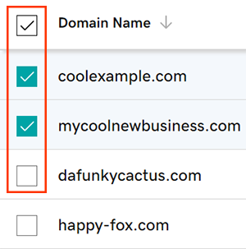

1. Select **Renew Now** from the action menu.
2. Choose your renewal settings, then select **Continue**.
3. Check the box next to **Turn on Auto-renew** to make sure your domain registration continues uninterrupted.
4. Finish renewing your domains during checkout in the cart.
5. Your updated expiration date will show in your account within 90 minutes.

* **Related steps:-**
* Avoid domain expiration by turning on **auto-renew.**
* Renewing your domain name does not renew your email or website. Don't forget **to renew your other products as well.**
* **Some domains** may have special requirements for renewals.
* **Set up 2-step verification** for the best security on your domains and account.
* **Protect your domain** from accidental expiration and unauthorized actions by adding or upgrading Domain Protection.
* Looking for a new domain? **Get your perfect domain today.**

**1.Log in to your Domains Dashboard:-**

**2.On the Domains page, select the domains you would like to renew:-**

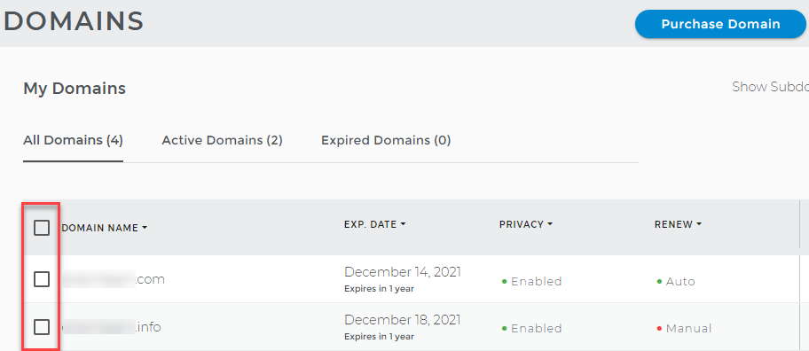

**3.Click Renew Domains from the drop-down menu:-**

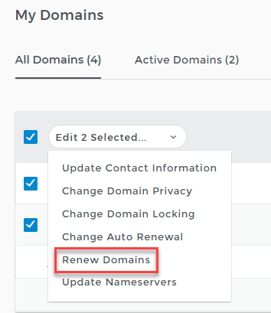

**4.Select how many years you want to renew the domains from the drop-down list.**

**5.Check the payment information and edit the card details if necessary.**

**6.Click the Purchase Items button.**

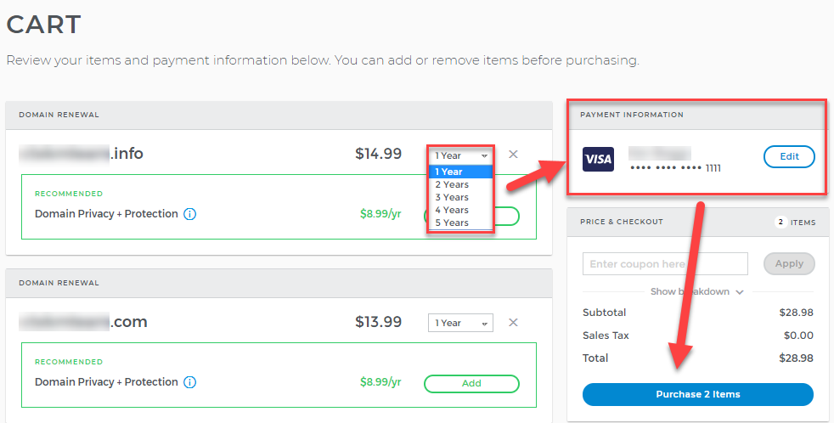

**7.You will be notified that your purchase is complete, and a confirmation email is sent to the account's administrative address.**

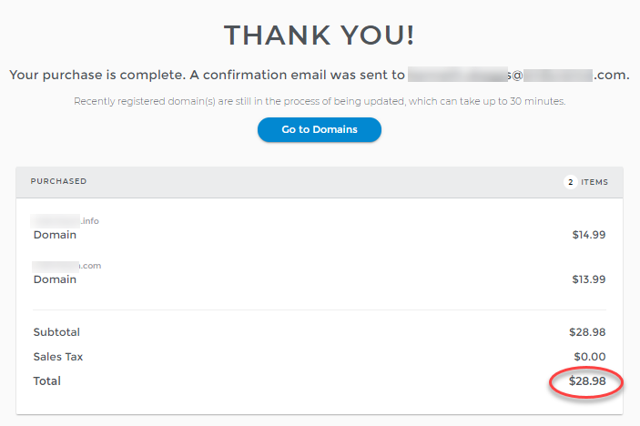

* **Web Server Management:-** Web server management is the process of maintaining and operating a server to ensure it performs optimally. This usually involves: Hardware updates, Software updates, Network optimization, and Security measures. Effective web server management can improve the user experience and ensure data security. A web server is a computer system that stores and serves website files. When a user visits a website, their browser requests the page's contents from the web server, which then delivers it to the user. Web servers can also support physical data interchange with other devices connected to the web. Web server management activity starts with the base configuration of the server, specifically for first-time use. This can include the hardware setup (in the case of physical or hybrid servers), operating system installation, and installing the applications and programs needed to run the server. What is Server Management? Server management involves all the monitoring and maintenance required for servers to operate reliably and at optimal performance levels. This includes managing hardware, software, security, and backups to keep the IT environment operational and efficient. On the hardware side, a web server is a computer that stores web server software and a website's component files (for example, HTML documents, images, CSS stylesheets, and JavaScript files). A web server connects to the Internet and supports physical data interchange with other devices connected to the web. Server management is the list of tasks that need to be done to guarantee the correct performance of different types of servers in a network. It requires IT professionals to access hardware and software that integrate the server in order to perform the required maintenance, updates, and monitoring.
  + **Web Server:-** A web server is software and hardware that uses HTTP (Hypertext Transfer Protocol) and other protocols to respond to client requests made over the World Wide Web. The main job of a web server is to display website content through storing, processing and delivering webpages to users. Besides HTTP, web servers also support SMTP (Simple Mail Transfer Protocol) and FTP (File Transfer Protocol), used for email, file transfer and storage. Web server hardware is connected to the internet and allows data to be exchanged with other connected devices, while web server software controls how a user accesses hosted files. The web server process is an example of the client/server model. All computers that host websites must have web server software. Web servers are used in web hosting, or the hosting of data for websites and web-based applications -- or web applications.
* **How do web servers work:-** Web server software is accessed through the domain names of websites and ensures the delivery of the site's content to the requesting user. The software side is also comprised of several components, with at least an HTTP server. The HTTP server is able to understand HTTP and URLs. As hardware, a web server is a computer that stores web server software and other files related to a website, such as HTML documents, images and JavaScript files. When a web browser, like Google Chrome or Firefox, needs a file that's hosted on a web server, the browser will request the file by HTTP. When the request is received by the web server, the HTTP server will accept the request, find the content and send it back to the browser through HTTP. More specifically, when a browser requests a page from a web server, the process will follow a series of steps. First, a person will specify a URL in a web browser's address bar. The web browser will then obtain the IP address of the domain name -- either translating the URL through DNS (Domain Name System) or by searching in its cache. This will bring the browser to a web server. The browser will then request the specific file from the web server by an HTTP request. The web server will respond, sending the browser the requested page, again, through HTTP. If the requested page does not exist or if something goes wrong, the web server will respond with an error message. The browser will then be able to display the webpage.

## Examples of web server uses:- Web servers often come as part of a larger package of internet- and intranet-related programs that are used for:-

* **sending and receiving emails;**
* **downloading requests for File Transfer Protocol (FTP) files; and**
* **building and publishing webpages.**

Many basic web servers will also support server-side scripting, which is used to employ scripts on a web server that can customize the response to the client. Server-side scripting runs on the server machine and typically has a broad feature set, which includes database access. The server-side scripting process will also use Active Server Pages (ASP), Hypertext Preprocessor (PHP) and other scripting languages. This process also allows HTML documents to be created dynamically.

* **Dynamic VS. Static Web Servers:-** A web server can be used to serve either static or dynamic content. Static refers to the content being shown as is, while dynamic content can be updated and changed. A static web server will consist of a computer and HTTP software. It is considered static because the sever will send hosted files as is to a browser. Dynamic web browsers will consist of a web server and other software such as an application server and database. It is considered dynamic because the application server can be used to update any hosted files before they are sent to a browser. The web server can generate content when it is requested from the database. Though this process is more flexible, it is also more complicated.
* **Apache HTTP Server:-**Developed by Apache Software Foundation, it is a free and open source web server for Windows, Mac OS X, Unix, Linux, Solaris and other operating systems; it needs the Apache license.
* **Microsoft Internet Information Services (IIS):-**Developed by Microsoft for Microsoft platforms; it is not open sourced, but widely used.
* **Nginx:-** A popular open source web server for administrators because of its light resource utilization and scalability. It can handle many concurrent sessions due to its event-driven architecture. Nginx also can be used as a proxy server and load balancer.
* **Lighttpd:-**A free web server that comes with the FreeBSD operating system. It is seen as fast and secure, while consuming less CPU power.
* **Sun Java System Web Server;-**A free web server from Sun Microsystems that can run on Windows, Linux and Unix. It is well-equipped to handle medium to large websites.

Leading web servers include Apache, Microsoft's Internet Information Services (IIS) and Nginx -- pronounced engine X. Other web servers include Novell's NetWare server, Google Web Server (GWS) and IBM's family of Domino servers. Considerations in choosing a web server include how well it works with the operating system and other servers; its ability to handle server-side programming; security characteristics; and the publishing, search engine and site-building tools that come with it. Web servers may also have different configurations and set default values. To create high performance, a web server, high throughput and low latency will help.

## Web Server Security:-

There are plenty of security practices individuals can set around web server use that can make for a safer experience. A few example security practices can include processes like:

* a reverse proxy, which is designed to hide an internal server and act as an intermediary for traffic originating on an internal server;
* access restriction through processes such as limiting the web host's access to infrastructure machines or using Secure Socket Shell (SSH);
* keeping web servers patched and up to date to help ensure the web server isn't susceptible to vulnerabilities;
* network monitoring to make sure there isn't any or unauthorized activity; and
* using a firewall and SSL as firewalls can monitor HTTP traffic while having a Secure Sockets Layer (SSL) can help keep data secure.

**Web Space:-** Web space, also known as storage space or disk space, is the amount of space on a web server that is allocated to a website owner. It's the space where all the files that make up a website are stored, including text files, images, scripts, databases, and emails. Web space is measured in bytes, kilobytes, and megabytes. When you pay for web space, you're renting space on a server so that people all over the world can access your website data. The so-called web space is a storage space for files on a server that can be accessed permanently via the Internet. Thus, when you pay for this storage space, you rent a space on a server so that users all over the world can access your website data. The web space, also known as storage space or disk space, generally refers to the amount of space on a web server that is allocated to website owners by the web hosting companies. It is made up of the total quantity of all text files, images, scripts, databases, emails and other files related to your website. There are several essential things a **web hosting** provider must actually provide. The first thing is a stable server, on which the **websites**should run. Once he has the physical machine, it's time to install suitable software, such as **Mail SMTP server** and **DNS server** software. And when everything is ready to go, the hosting provider must face the hardest task - to define his offers. And one of the features every client first looks for is the web space. The web space, also known as storage space or disk space, generally refers to the amount of space on a web server that is allocated to website owners by the web hosting companies. It is made up of the total quantity of all text files, images, scripts, databases, emails and other files related to your website.

Having an idea of the web space demands for your web presence will help you choose the right web hosting plan configuration. Thus, you will feel secure about the online availability of your uploaded content and hence - for your web image. This will make your uploaded content always available online and your virtual profile - invulnerable to shortage in resources

* **Web Space Functions:-** The web space can serve two basic purposes. In the first place, it allows you to upload file information (HTML files, image files, etc.) on the World Wide Web where it will be available at a global scale. Second, this resource enables you to store various files that are not visible to website visitors but play an important role for the proper functioning of your website.

Some of the popular 'invisible' files taking up web space on the server where your website is located are PHP files, database files and CGI program files. PHP files are stored on the server with a .php extension and are used for various important on-site activities such as order form processing for online stores, poll results management, etc. Databases, in turn, store data such as product codes, customer details, etc., which is retrieved by PHP scrips and CGI programs. CGI programs serve for processing data inputs from online forms, which require that the collected information be stored on the website's server.

Other web space occupying files worth mentioning include externally linked CSS files and JavaScript files. External CSS files, responsible for defining the style elements of a web page, are stored on the web hosting server and linked to each web page requiring them. JavaScript files, also linked to web pages needing them, lie in the basis of dynamic drop-down menus, visitor counters, etc., i.e. they work for increasing the interactivity of a website.

Log files are other website-related data containers that eat up your allocated web space. They contain important details about your website visitors' behavior, generated through requests sent from your website to the web server. The email accounts and the separate email messages are also considered as disk space consumers. The storage amount they occupy is usually added to the web space quota of the regular web hosting plans.

As you can see, the web space you need to launch a website on the World Wide Web is not used only for accommodating files visible to the visitor's eye. It also refers to storing files and programs that lie in the background of a website, but are responsible for supporting its interactivity, dynamic content, statistics and e-mail communication. In this light, when estimating your web space demands, you need to first total the quantity of your website files on your computer and then add approximately estimated space for databases, emails, log files, etc. In view of your website's future smooth expansion, you should add at least half of the whole estimated space to the calculation you have made so far. Now it will be much easier for you to find the right web hosting account configuration.

* **Web Space Measurement:-** he web space is generally measured in bytes, kilobytes (1,000 bytes), megabytes (1,000 kilobytes) and gigabytes (1,000 megabytes) on both personal computers and web servers. Since disk space has lately become a comparatively cheap web hosting resource, it is usually offered in gigabyte quantities with standard plans. Megabytes are represented with "MB" and gigabytes with "GB". A popular web hosting trick is to represent disk space in smaller units, in order to impress the customers.

## Web Space with NTC Hosting:- All NTC's web hosting offers come with enough disk space for any type of sites - from a small personal site to a complex company web page or a popular online e-commerce store. Disk space can be easily monitored at all times from both the Accounts usage table in the Web Hosting Control Panel and via a neat graph in the File Manager.

* **Storage space (megabytes):-on our server that stores all of your web pages, images, sounds, email, scripts, or any other information your web page references**
* [**The space on the world wide web dedicated to hosting web sites TOP**](https://www.seslisozluk.net/en/what-is-the-meaning-of-the-space-on-the-world-wide-web-dedicated-to-hosting-web-sites-top/)
* [**This term refers to the space created by the World Wide Web**](https://www.seslisozluk.net/en/what-is-the-meaning-of-this-term-refers-to-the-space-created-by-the-world-wide-web/)
* [**disk space on a web server for storing web pages**](https://www.seslisozluk.net/en/what-is-the-meaning-of-disk-space-on-a-web-server-for-storing-web-pages/)
* **this term refers to the allocated space from the service provider on their Internet servers**
* **usually refers to space on a web server provided to Internet users so that they can create and publish their own web sites**
* [**The "space" within which the World Wide Web exists in cyberspace**](https://www.seslisozluk.net/en/what-is-the-meaning-of-the-%22space%22-within-which-the-world-wide-web-exists-in-cyberspace/)
* **The space on a Web dedicated to hosting Web sites Many Internet Service Providers give away free Web space so that you can build your own Web site**
* **Storage space on the chello (or any other) Web server You can, for example, upload your own home page to your Web space, and in this way other users are able to access the files directly from the Web server**
* **Amount of web space provided by a web host for a specific plan Amount listed is in MBs**
* **Web space refers to the amount of storage space you are allocated on our server It is measured in megabytes (MB) Your web pages themselves (the html files) take up web space All other files, such as images, CGI scripts, etc, take up web space as well Our different web accounts offer different amounts of storage space to fit your needs Return to Top**
* [**The disk space on a Web Server that is set aside for a Web site**](https://www.seslisozluk.net/en/what-is-the-meaning-of-the-disk-space-on-a-web-server-that-is-set-aside-for-a-web-site/)
* **The amount of storage space that your Internet Service Provider (ISP) gives you to use for your own personal web page Normally between 2 megabytes and 10 megabytes**
* **This is the space that is allocated to you on the server It is how much space you will have to put your web pages, images, videos, and anything you chose to store on your web space Click Here to Close this Window**
* [**is a storage area where you keep your Web site**](https://www.seslisozluk.net/en/what-is-the-meaning-of-is-a-storage-area-where-you-keep-your-web-site/)
* **Web space is the amount of disk storage space you are allowed on the server Do not confuse web space with bandwidth web space is the amount of storage space for your files where bandwidth refers to the amount of data transferred from your account to people requesting those files Baird Technology Group allows you to have 50 Megabytes of space for each account This web space is used for files needed for your web site and including HTML files ( html, htm, shtml), images ( gif, jpg), executables and compressed files ( exe, tar, zip) and other files ( cgi, pl, txt, log) 50 Megabytes of web space is quite a lot of space and should be sufficient for all of your files**

### Types Of Web Server:- Web server is a program which processes the network requests of the users and serves them with files that create web pages. This exchange takes place using Hypertext Transfer Protocol (HTTP). Basically, web servers are computers used to store HTTP files which makes a website and when a client requests a certain website, it delivers the requested website to the client. For example, you want to open Facebook on your laptop and enter the URL in the search bar of google. Now, the laptop will send an HTTP request to view the facebook webpage to another computer known as the webserver. This computer (webserver) contains all the files (usually in HTTP format) which make up the website like text, images, gif files, etc. After processing the request, the webserver will send the requested website-related files to your computer and then you can reach the website. Different websites can be stored on the same or different web servers but that doesn’t affect the actual website that you are seeing in your computer. The web server can be any software or hardware but is usually a software running on a computer. One web server can handle multiple users at any given time which is a necessity otherwise there had to be a web server for each user and considering the current world population, is nearly close to impossible. A web server is never disconnected from the internet because if it was, then it won’t be able to receive any requests, and therefore cannot process them.

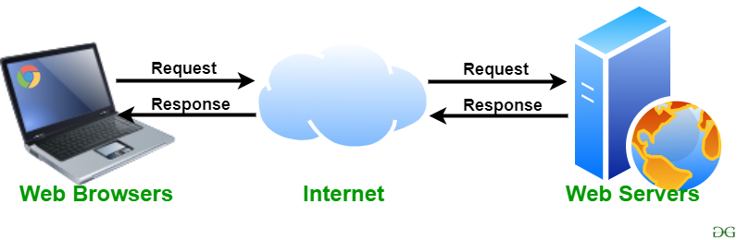

There are many web servers available in the market both free and paid. Some of them are described below:-

* **Apache HTTP server:-** It is the most popular web server and about 60 percent of the world’s web server machines run this web server. The Apache HTTP web server was developed by the Apache Software Foundation. It is an open-source software which means that we can access and make changes to its code and mold it according to our preference. The Apache Web Server can be installed and operated easily on almost all operating systems like Linux, MacOS, Windows, etc. A program that uses HTTP for serving files that create web pages for users in response to their requests that are sent by the HTTP clients of their computer is called as a web server.

If any server delivers an XML document to another device, it can be a web server. In simple words, a web server is an Internet server that responds to HTTP requests for delivering content and services.

Let’s take an example, if you are working on your computer, browsing your web and a message pop ups from your friend that “I had just read a great article at the following URL: https://www.milesweb.in/blog”.

So, you will insert this URL into your browser and press enter. That’s it!

The web server on which your website is based in the world doesn’t matter at all as the page you have browsed immediately appears on your computer screen.

A web server is never disconnected from internet. Each of the web servers has a unique address that comprises of a series of four numbers between 0 and 255. These numbers are separated with a period (.).

With the web server, the hosting providers can manage multiple domains (users) on a single server.

A **web hosting provider** rents the space on a server or cluster of servers for people to create their online presence with a website.

## https://media.geeksforgeeks.org/wp-content/uploads/20190927171921/apache.png

* **Microsoft Internet Information Services (IIS):** IIS (Internet Information Services) is a high performing web server developed by Microsoft. It is strongly united with the operating system and is therefore relatively easier to administer. It is developed by Microsoft, it has a good customer support system which is easier to access if we encounter any issue with the server. It has all the features of the Apache HTTP Server except that it is not an open-source software and therefore its code is inaccessible which means that we cannot make changes in the code to suit our needs. It can be easily installed in any Windows device. A Microsoft product, IIS is a server that offers all the features such as Apache. Since it’s not an open source, adding personal modules as well as modifying becomes a bit difficult. It supports all the platforms that run Windows operating system. Additionally, you also get good customer support, if there is any issue.



**Lighttpd:-** Lighttpd is pronounced as ‘Lightly’. It currently runs about 0.1 percent of the world’s websites. Lighttpd has a small CPU load and is therefore comparatively easier to run. It has a low memory footprint and hence in comparison to the other web servers, requires less memory space to run which is always an advantage. It also has speed optimizations which means that we can optimize or change its speed according to our requirements. It is an open-source software which means that we can access its code and add changes to it according to our needs and then upload our own module (the changed code). A high-performance Apache drop-in replacement, LiteSpeed (LSWS) is the 4th popular web server on the internet and is a commercial web server. When you upgrade your web server to LiteSpeed, you will experience improved performance that too with low operating cost. This server is compatible with the most common Apache features such as .htaccess, mod_rewrite and mod_security. It has the ability to load Apache configuration files directly and work as a drop in replacement Apache with almost all the hosting control panels. It can replace the Apache within 15 minutes without any downtime. LSWS replaces all the Apache functions which other front-end proxy solutions can’t do to simplify the use and make the transition from Apache smooth and easy.

## https://media.geeksforgeeks.org/wp-content/uploads/20190927171929/lighttpd.png

**Jigsaw Server:-** Jigsaw has been written in the Java language and it can run CGI (common gateway interference) scripts as well as PHP programs. It is not a full-fledged server and was developed as an experimental server to demonstrate the new web protocols. It is an open-source software which means that we can access its code and add changes to it according to our needs and then upload our own module (the changed code). It can be installed on any device provided that the device supports Java language and modifications in Java.



* **Sun Java System:**-The Sun Java System supports various languages, scripts, and technologies required for Web 2.0 such as Python, PHP, etc. It is not an open-source software and therefore its code is inaccessible which means that we cannot make changes in the code to suit our needs.



* **Nginx Web Server:-** Nginx is the next open source web server after Apache. It comprises of IMAP/POP3 proxy server. The significant features offered by Nginx are high performance, stability, simple configuration and low resource usage.

No threads are used to handle the requests by Nginx, instead a highly scalable event-driven architecture that uses small and predictable amount of memory under load is utilized. It has become popular recently and hosts about 7.5% of all the domains globally. Many web hosting companies have started using this server.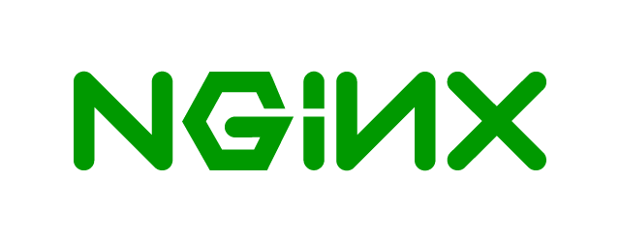

* **Apache Tomcat:-** An open source Java servlet container, Apache Tomcat functions as a web server. A Java program that expands the capabilities of a server is called as a **Java servlet**.  Servlets can respond to any types of requests but they most commonly implement applications hosted on web servers. These web servlets are Java equivalent to other dynamic web content technologies such as PHP and ASP.NET. Sun Microsystems donated Tomcat’s code base to the Apache Software Foundation in 1999 which became a top-level Apache project in 2005. Currently, it powers just under **1% of all websites**. Released under the Apache License version 2, Apache Tomcat is typically used to run Java applications. But, it can be extended with **Coyote**, so that it can also perform the role of a normal web server that serves local files as HTTP documents.

Often, Apache Tomcat is listed among other open source Java application servers. Some examples are **Wildfly**, **JBoss**, and **Glassfish**.



* **Node.JS:-** Node.js is basically a server-side JavaScript environment that is used for network applications such as web servers. It was originally written by Ryan Dahl in 2009. Having a smaller market position, Node.js runs **0.2% of all websites**. The Node.js project, managed by the Node.js Foundation, is assisted by the Linux Foundation’s Collaborative Projects program. Node.js differs from other popular web servers because it is mainly a cross-platform runtime environment for building network applications with. An event-driven architecture is applied by Node.js which is capable of asynchronous I/O. Due to these design choices throughput and scalability are optimized in web applications which helps to run real-time communication and browser games. Node.js also helps in understanding the difference in web development stacks, where Node.js is clearly part of the HTML, CSS, and JavaScript stack, as opposed to Apache or NGINX which are a part of several different software stacks.

Node.js is released under a **mix of licenses**.

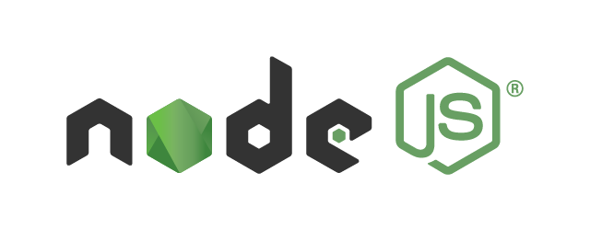

* **OpenLiteSpeed:-** A high-performing and lightweight server that helps your website load super-fast. It’s basically the Open Source edition of LiteSpeed Web Server Enterprise. You get simplicity, as it’s free to download, use, distribute and easily modify.

Next, OpenLiteSpeed combines all the benchmarks such as, speed, security, optimization & scalability, in just a single open-source package. On top of this, it’s based on Event Driven Architecture, resulting in less overheads & amazing scalability.

The current stats say it’s been used by **12.2% of all the websites**. The number is really notable!

OpenLiteSpeed is compatible with mod_rewrite, so you don’t have to worry about learning new syntax. Plus, handles thousands of concurrent connections with zero load spikes, supports HTTP/3 and QUIC, external apps like, PHP, Ruby, Python, Perl, and Java. You can experience a serious performance boost by switching to OpenLiteSpeed web servers. 

* **Jigsaw Server:-** Jigsaw is an object oriented and leading web server platform. It offers a sample HTTP 1.1 implementation and a range of premium features above its advanced architecture implemented in Java. Jigsaw Server is developed by World Wide Web Consortium (W3C). It runs about 0.1 percent of the world’s websites.

It’s a completely free and open-source platform! You can run on various platforms like Linux, Windows, Mac OS X Free BSD, etc.

Further, this Jigsaw server gives developers the platform to test out new features and implement them according to the changing web standards.



### ****Mail Server**:-** In a mail server, you get a centrally-located pool of disk space to store and share different documents in the form of emails for network users. All the data is stored in a single location and so, administrators need to backup files only from one computer.

### ****Application Server:-**** It acts as a set of components which can be accessed by the software developer via an API defined by the platform itself. These components are usually performed in the environment similar to its web server(s) for the web applications. Their main job is to support the construction of dynamic pages.

* **File Transfer Protocol (FTP) Server:**-A separate control and data connections are used by the FTP between the client and the server. It is possible for the FTP users to authorize themselves in the form of a username and password. However, they can connect using anonymous names, if the server isn’t configured to allow them. For transmission security, the username and password need to be encrypted using the FTP and SSL.
* **Database Server:**- A computer program that offers database services to other computer programs or computers with the use of client-server functionality is called as a database server. There are some DBMSs (example: MySQL) depend on the client-server model for database access. This type of server is accessible either via a “front end” that runs on the user’s computer where the request is made or the “back end” where it is served such as data analysis and storage.
* **Domain Name System (DNS) Server:**- A computer server that hosts a network service for offering responses to queries is called a name server. It maps either an addressing component or numeric identification. This is done by the server to give response to a network service protocol request.

These DNS servers primarily translate the human- memorable domain names and host names into the corresponding numeric Internet protocol (IP) addresses. DNS also helps to recognize a namespace of the Internet, used to identify and locate computer systems and resources on the Internet.

Top of Form

Bottom of Form